# Lab: Asynchronous Programming

Problems for exercises and homework for the ["JavaScript Apps" course @ SoftUni.](https://softuni.bg/trainings/3589/js-applications-february-2022)  
The following tasks do not have tests in the Judge system. They are for practice.

**Working with Remote Data**

For the solution of some of the following tasks, you will need to use an up-to-date version of the **local REST service**, provided in the lesson’s resources archive. You can [read the documentation here](https://github.com/softuni-practice-server/softuni-practice-server).

## Cookbook – Part 1

The resources for this task are available in the following GitHub repository:

<https://github.com/viktorpts/js-apps-workshop>

You may check-out the repository or download the files via the green button labeled "Code" in the upper-right corner. Use the files located in **lesson-02/base** to begin the task. Before starting, make sure you have the most recent version of the repository. To see the solution, check the files inside **lesson-02/finished**.

Write a JS program that loads all recipies from the provided local server. You are **provided with skeleton** (**HTML & CSS**) for this task, also with **server**, which you will use as localhost. You will be able to load from the server "database" the needed recipies and other details.

### Load all recipies

When the app is started, you need to **load all the recipies** from the server:

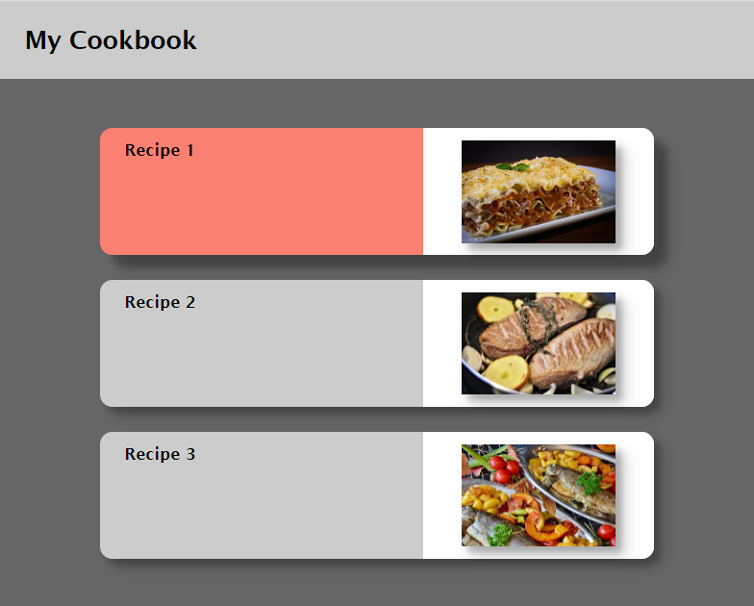

You have to make **"GET" request** to the server on this **URL**: <http://localhost:3030/jsonstore/cookbook/recipes>

### Load selected recipe

By **clicking on a card** with recipe you need to make a **"GET" request** to the server, and **toggle** **the information** only for the **selected recipe**.

The **URL** for the details is: [http://localhost:3030/jsonstore/cookbook/details/**:id**](http://localhost:3030/jsonstore/cookbook/details/:id)

Where **":id"** is the id of the selected recipe.

